how to build a team for your localization projects (invite a freelance translator, co-worker or a partner company). How these team members can co-operate and what they can and cannot do in the company account

**Collaboration in Text United**

Collaboration is the backbone of every translation project. A platform that enables multiple people to work on a translation project has to provide adequate collaboration features and insight for progress.

With Text United all participants of a translation project can interact on a professional level, for each translation segment they can exchange comments and reference material, and the Project Manager can review and leave comments as well.

**How to build a team for localization projects in Text United.**

Text United enables you to organize localization projects for your company internally. For organizing a localization project you will need to have a team of translators, proofreaders and reviewers. There are four types of users in company accounts:

* **Administrator**, has all permissions in the system, upgrading and downgrading users, managing subscription and payments.
* **Power user**, this is basically the project manager, he can order paid translation projects and edit terminology in the company dictionary
* **User**, can only receive translation projects and create projects within the company
* **Freelance translator**, he is not part of your company account but part of the Text United translator database, but you can add him to the list of your team members. A freelance translator cannot order project, only receive tasks

Creating your team and inviting them is very simple. From the My Team section in the portal, you have the option to invite users to your team. As soon as you enter their mail and invite them, they will be registered to Text United as ‘users’ of your company account.

The invited users receive a confirmation link which will activate the account and a temporary password that allows them to login to the system and start using it right away.

**How does the workflow of a localization project looks like in Text United**

* The project manager creates a new localization project
* In the project setup wizard he is able to choose if he wants to create an Internal project that will be translated by his team members or outsource to Text United.
* When the project manager chooses the internal project option, he has to assign a translator and a proofreader for each target language
* When the project is created, team members receive notifications and have to login to the portal to start working on the translation task
* The project manager has the options to preview the translations, accept and reject individual segments of translated text
* The project manager can keep track of the progress and leave comments on individual segments
* The project manager can upload reference images to segments which translators and proofreaders can open and preview
* Reference files can be uploaded in the project setup or afterwards and these are available for translators and proofreaders as well

The project manager and administrator both have insight in the project at any time. They can monitor progress of the project and interact with the translators and proofreader by previewing their translations and leave comments. From the project details page, the project manager has the following options:

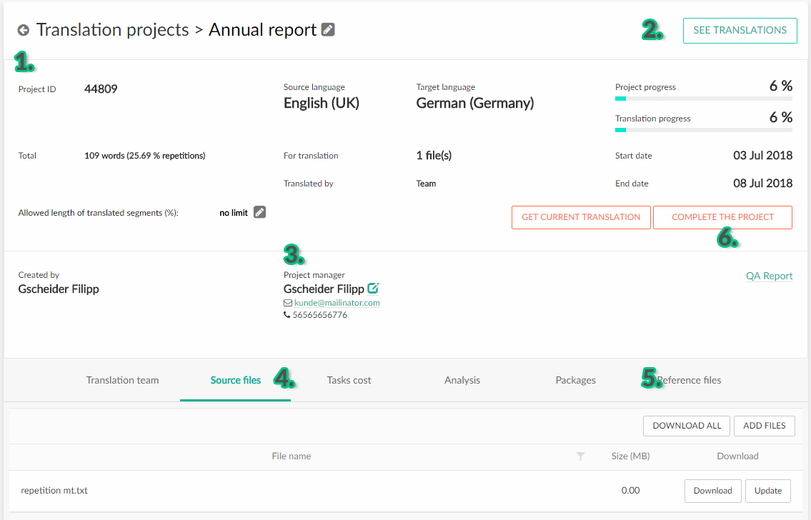

1. Preview project details and basic information
2. Preview translations, leave comments, upload reference images
3. Change the project manager (change who will be in charge of the translation project to a different team member)
4. Change source files (add new files to the project or change existing files with the option UPDATE)
5. Add reference files to the project
6. Complete the project (Use this option when a the team members have finished the task or if you want to abort the translation and archive the project)

**Benefits of company accounts**

All users of a company account share the same Translation Memory and Terminology repository. Everything that is translated is kept consistent because your translators will have access to the same terminology and translation memory entries.

If new terms are added to a project during the translation process, those are saved to the project’s glossary. After completing the project, everything from the glossary is saved to your default terminology repository. The administrator or Power user is able to review, edit, accept or reject individual segments in the Company Dictionary.